**Quarterly Report – Public Page**

**Date of Report:** 6th Quarterly Report - April 1, 2024

**Contract Number:** *693JK32210015POTA*

**Prepared for:** *DOT-PHMSA*

**Project Title:** *Dynamic Geohazard Risk and Decision Support Platform*

**Prepared by:**  *Boston Geospatial, Inc.*

**Contact Information:**  *Justin Oliveira,* [*justin@bostongeospatial.com*](mailto:justin@bostongeospatial.com)*, 321-720-3568*

**For quarterly period ending:** *March 31, 2024*

**1: Items Completed During this Quarterly Period:**

A detailed overview of the progress this past quarter is provided in the various sections below.

| ***Item #*** | ***Task #*** | ***Activity/Deliverable*** | ***Title*** |
| --- | --- | --- | --- |
| 13 | 3.2 | Geohazards Module | Post-process InSAR measurements for TAP operators assetbase into geodatabase; Develop API wrapper for geohazard geodatabases |
| 14 | 3.3 | Geohazards Module | Submit Geohazards API and Methodology Documentation |
| 15 | 4.1 | Load Case Module | Develop library to extract prior seismic event load case boundary conditions (acceleration loads) and ground kinematics conditions (subsidence loads) |
| 20 | 4.2 | Load Case Module | Implement fault line risk and project ground kinematics forecasting library |
| 27 | 0.1 | 6th Quarterly Status Report | Submit 6th quarterly report |

**2: Items Not-Completed During this Quarterly Period:**

| ***Item #*** | ***Task #*** | ***Activity/Deliverable*** | ***Title*** |
| --- | --- | --- | --- |
| 21 | 4.3 | Load Case Module | Submit Load Case API Documentation |
| 18 | 6.1 | GIS Interface | ArcGIS interface initialization, geodatabase connections, and dashboard setup |
| 22 | 6.2 | GIS Interface | ArcGIS Web Portal Setup |
| 23 | 6.3 | GIS Interface | Submit GIS Implementation Guideline Documentation |
| 24 | 7.1 | Integration | API service integration and client management setup; ArcGIS tool ribbon development |
| 25 | 7.2 | Integration | Submit consolidated API documentation and ArcGIS ribbon user's manual |
| 26 | 8.1 | Backtesting | Backtesting of tool with TAP operators |

**3: Project Financial Tracking During this Quarterly Period:**

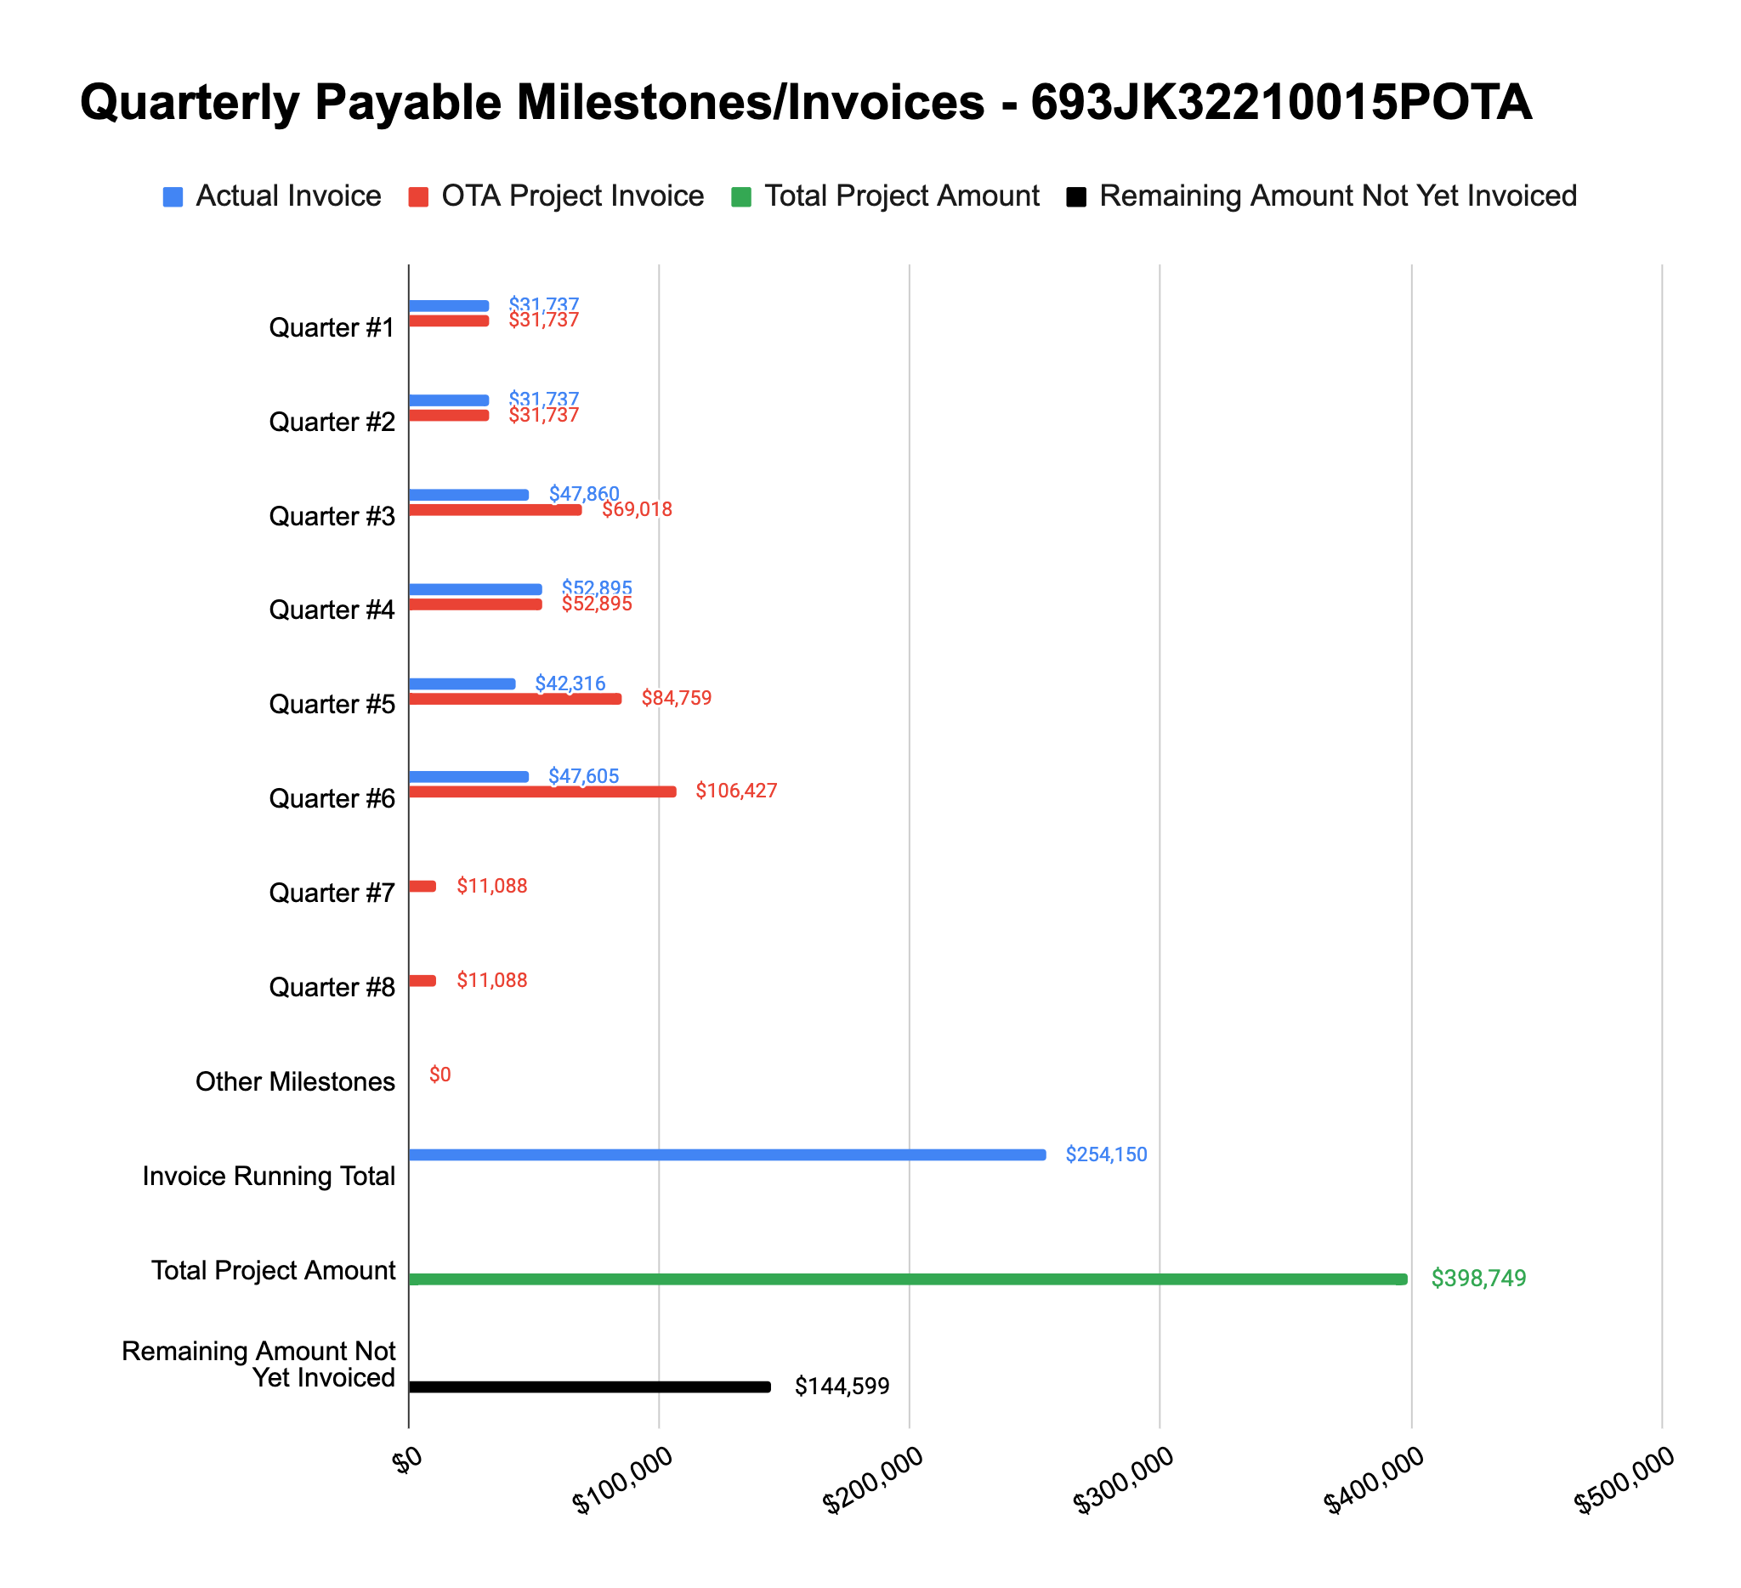

**4: Project Technical Status –**

**Item# 13 / Task# 3.2/ Geohazards Module / Post-process InSAR measurements for TAP operators asset base into geodatabase; Develop API wrapper for geohazard geodatabases**

Since our Q5 status report, we have completed all work associated with this task. We have made improvements to our existing slope susceptibility capability for use in the tool - the enhancement makes a rough estimate of both the direction and runout length of at-risk slope sections. These details are needed to feed into the load case equations associated with landslide pipe loading. We also made improvements to our existing sinkhole susceptibility capability - the enhancement adds the average dimensions of sinkholes based on the primary rock type at any given location based on actual/reported sinkholes. This updated geodatabase allows for crossing analyses to be performed against the pipe network and feeds the dead and live load estimations. Another key piece of this item was adding sample data to the earth movement geodatabase extracted from InSAR measurements. We plan to add more sample data as we transition into tool benchmarking - either for areas around TAP assets or from PHMSA geohazard case studies from the 2021 Notice. In adding and integrating the sample data within the tool and geodatabase, we realized the need for a new library that better helps convert the earth movement kinematics from the InSAR measurements into geodetic components but specific to the area above and adjacent to the pipe centerline for load case modeling. This effort introduced some delays but is now complete and integrated into the software.

**Item# 14 / Task# 3.3/ Geohazards Module / Submit Geohazards API and Methodology Documentation**

Since our Q5 status report, we have completed all work associated with this task. The deliverable was uploaded to PRIMIS on April 1st.

**Item# 15 / Task# 4.1/ Load Case Module / Develop library to extract prior seismic event load case boundary conditions (acceleration loads) and ground kinematics conditions (subsidence loads)**

Since our Q5 status report, we have completed all work associated with this task. The tool supports the extraction of geohazard loads associated with seismic and earth movement from geodatabases - this is done for each segment of the pipe network within the pipeline data model. It includes libraries that also perform a coordinate frame transformation for the earth movement (subsidence) loads as well as any fault slip movement into the pipe frame. The ground kinematics associated with earth movement (resolved by satellite radar interferometry) are in a geodetic frame (up, north, east) and must be converted into the local pipe segment frame so that the loads can be applied and stress estimated properly.

**Item# 20 / Task# 4.2/ Load Case Module / Implement fault line risk and project ground kinematics forecasting library**

Since our Q5 status report, we have completed all work associated with this task. Once the earth movement and/or fault movement relative to the pipe is found (using the libraries completed in Task 4.1), libraries were added to forecast the associated displacements (relative to the pipe) to a point in the future (e.g. next baseline assessment date, end of design life date, etc.) for use in load case modeling.

**Item# 21 / Task# 4.3/ Load Case Module / Submit Load Case API Documentation**

Since our Q5 report, we’ve made considerable progress on Task Area 4. Currently, outside of ArcGIS, we have demonstrated end-to-end execution of the entire tool using sample pipeline input data - a big accomplishment and testament to the team’s hard work. The documentation associated with the Load Case Module shouldn’t take more than a couple weeks to finalize - it will be submitted well before the next quarterly update via PRIMIS.

**Item# 18 / Task# 6.1/ GIS Interface / ArcGIS interface initialization, geodatabase connections, and dashboard setup**

With the initial datasets in place and connections to existing cloud-based, postgres geohazard geodatabases we have deployed ready, the remaining work is associated with the visual design of the dashboard view within ArcGIS. This will show a summary view of the most recent tool run. With work done now under Task Area 3, we can now focus our attention on accelerating Task Area 6 and believe we can complete Item 18 within about a month.

**Item# 22 / Task# 6.2/ GIS Interface / ArcGIS Web Portal Setup**

Work on this item will be delayed until the completion of Item 18 is completed.

**Item# 23 / Task# 6.3/ GIS Interface / Submit GIS Implementation Guideline Documentation**

Work on this item will be delayed until the completion of Item 18 and 22 are completed.

**Item# 24 / Task# 7.1/ Integration / API service integration and client management setup; ArcGIS tool ribbon development**

Since last quarter, we have made progress on drafting a process on how we plan to issue end-user credentials to the tool’s APIs as well as how “installation” of the tool will be done. However, given that we have not been able to secure an operator yet for our TAP, we will be limited in our ability to dry-run any end-user integrations beyond using Esri-provided UPDM models and those we make ourselves based on public information surrounding case studies from the 2021 PHMSA Geohazard Notice. Work associated with ArcGIS ArcPy and any UI functionality will be delayed until the completion of Item 22 and 23.

**Item# 25 / Task# 7.2/ Integration / Submit consolidated API documentation and ArcGIS ribbon user's manual**

Work on this item will be delayed until the completion of Item 24 is completed.

**Item# 26 / Task# 8.1/ Integration / Backtesting of tool with TAP operators**

Please refer to our comments in the Item 24 section above.

**Item# 27 / Task# 0.1/ 6th Quarterly Status Report / Submit 6th quarterly report**

Additional detail not necessary - this report constitutes the deliverable for Item# 27 / Task# 0.1.

**5: Project Schedule –**

Overall our project is about 5-7 weeks behind schedule. The work associated with the Geohazard Module (one of the most significant pieces of the tool and by far the largest contribution to the community) took a lot longer than expected but is now complete. Over the next couple weeks, clean up work and closeout of Item 21 will be performed - once done, it will be much easier to accelerate progress and complete work associated with Task Area 6 and 7. In parallel over the next couple weeks, we’ll be completing some initial backtesting of a handful of case studies to present at AGA - these case studies come from the 2021 PHMSA Geohazard Notice as well as geohazard-related incidents from the PHMSA database. A copy of the slides used for our talk will be uploaded to PRIMIS in the coming weeks.